THE WELSH OPEN CANOE SYMPOSIUM 2025

The symposium is grateful for the support from

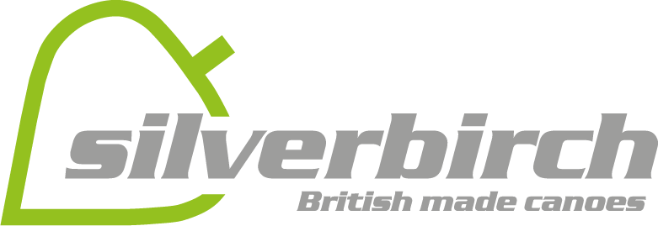

It has been a hectic time and we are going to attempt to get folk to pre book workshops for the first day. But all subject to water and weather.

NOTE: If you have booked accomodation please bring a sleeping bag.

No food provided on Friday but bar will be open. Lots of food outlets in Bala

Event Programme & General Timeline

Day | Time | Event or Activity | Location
Friday | 6.00pm  7.00pm  8.00pm  8.15pm  9.15pm | Event Reception Opens For Registration.  For those not pre booked  Sign Up for Saturday workshops.  Bar Opens.  Introduction & Welcome  Lecture: Bloodvein River  Nikki and Martin Aldridge  Lecture: The Wind River  Ollie Sandeman  Bar Closes | Main Hall / Bar Area  Main Hall / Bar Area  Lecture Theatre  Lecture Theatre
Saturday | 07.30am  08.00am  08.30am  8.45am  9.00am  9.30am  10.00am  12.30pm  1.30pm  4.30pm  5.30pm  6.30pm  8.00pm | Breakfast open for coaches  Breakfast served to all (please let coaches go to head of queue)  Staff Meeting For All Coaches  Breakfast Stops Serving  Official Opening Of The Symposium  Coaches Meet Workshops  Collect Your Packed Lunch  Workshops Commence  Morning Workshops Finish  Lunch  Coaches Meet Workshops  Afternoon Workshops Commence  All Workshops Finish  A number of workshops and short talks will be advertised. No booking required. TBC on the day. Silverbirch will be running boat repairs. Coaches will be offering a variety of walk-in sessions.  Dinner Served  4 talks: 20 min per talk with 10 min Q&A Hosted by  Dave Janes  Emily Williams Awaiting Title  Richard Harpham AwaitingTitle  Emy Macloed-A year of British canoe expeditions  Stu Sharpness and/or Leo Hoare-Mongolia | Dining Room  Event Reception  Main Hall / Bar  Main Hall / Bar  Main Hall / Bar  Meet in the Sports Hall and then divide off  Lecture Theatre
Sunday | 7.30am  8.00am  8.30am  8.45  9.00am  9.30am  10.00am  12.30pm  1.30pm  4.00pm | Breakfast Served Coaches  Breakfast  Collect Your Packed Lunch Here Too)  Staff Meeting For All Coaches  Breakfast Ends  Official Closing & Thank You  Coaches Meet Workshops  Workshops Commence  Morning Workshops Finish  Lunch  Coaches Meet Workshops  Afternoon Workshops Commence  All Workshops Finish  Depart | Dining Room  Event Reception  Main Hall / Bar  Main Hall / Bar

